SIF 3.0 Framework (.NET)
Version 0.13.0
Demo Usage Guide
Author: Rafidzal Rafiq, SIF Solution Engineer
Revision: 1.01
Published: Sep 2014
Copyright © 2026, Systemic Pty Ltd
Table of Contents
1. Introduction 3
1.1. Target audience 3
1.2. Scope 3
2. Technical details 3
2.1. Configuring an Environment 4
2.2. Starting the services 4
2.2.1. Starting the Environment Provider 4
2.2.2. Starting the StudentPersonal Provider 4
2.2.3. Starting the StudentPersonal Consumer 5
2.3. Reviewing expected behaviour 5
2.4. Explaining service choreography 5
2.5. Transitioning from the demo 5
2.5.1. Configuring an Environment 5
2.5.2. Implementing an Object Service Provider 6
2.5.3. Implementing a Service Consumer 7
2.6. Running the demo over a LAN 8
2.6.1. Configure local IIS Express instance 8
2.6.2. Grant remote access 8
2.6.3. Configure firewall access 9
2.6.4. Configure Visual Studio 12
2.6.5. Configure the StudentPersonal Consumer 12
2.6.6. Configure the Environment definition 12

Introduction
The demo projects included with the SIF 3.0 Framework were developed to illustrate framework usage. They were designed to run out of the box with minimal configuration. From an understanding of these projects, a developer should be able to create simple Service Consumers and Object Service Providers relatively quickly.
This document describes various technical aspects of the demo projects including (but are not limited to):
- Configuring an Environment
- Starting the services
- Reviewing expected behaviour
- Explaining service choreography
- Transitioning from the demo to a working application

Target audience
The intended audience for this document are developers who want to get hands-on experience with SIF 3.0 development in .NET. A basic understanding of SIF 3.0 concepts and terminology would be beneficial for understanding how the demo projects interact.

Scope
The scope of this document is to provide instructions on how to run the demo projects. It is outside the scope of this document to describe the SIF 3.0 specification or the underlying technologies used by the framework. It is expected that before attempting to run the demo projects, the developer has read the Sif3Framework .NET Developer’s Guide.

Technical details
In running this demo, the following steps are performed:
- Create an Environment
- Start the Environment Provider
- Start the StudentPersonal provider
- Run the StudentPersonal consumer
The sections that follow provide greater detail on each step.

Configuring an Environment
Before a Service Consumer and Object Service Provider can interact, an Environment must be created to manage the session information between them. Once an Environment has been defined, then the Service Consumer and Object Service Provider are able to register to that Environment. This registration is managed by an Environment Provider.
Environment definition generally falls under the domain of a SIF Administrator. However, creation of an initial Environment for this demo is performed by running the Scripts\BAT\Demo execution\DemoSetup.bat script. This script uses the Sif.Framework.Demo.Setup project to create and populate some demo databases with an initial Environment definition and test StudentPersonal data. By default, the database used can be found under the Data\Databases\SQLite directory. A SQLite database is used as no configuration changes are required to be able to run this demo out of the box.
All mandatory information associated with the applications (e.g. applicationKey, sharedSecret) have been predefined for this demo.
If this demo needs to be run against a different database, then the Demo.cfg.xml and SifFramework.cfg.xml files (in all demo projects) need to be updated accordingly.

Starting the services
This demo is made up of 3 components; a consumer of StudentPersonal data, a provider of StudentPersonal data and an Environment Provider. The consumer is a standalone application, whereas both providers are Web API services that require IIS.
For this demo, the providers are run using IIS Express from within Visual Studio 2013.

Starting the Environment Provider
To do so, load the Sif3Framework.sln Solution into Visual Studio and simply run it (by clicking on the Internet Explorer button shown below).
If the Internet Explorer button is not visible, it will be necessary to make the Sif.Framework.EnvironmentProvider project of the Solution the single start-up project.
The Sif.Framework.EnvironmentProvider project has been configured to run in IIS Express on a particular port (as specified in the project properties). This ports is referenced in the Environment configured from the previous section.
For the moment, ignore the “HTTP Error 403.14 – Forbidden” message that appears in the popped up Internet Explorer window on start-up. As this is a Web API service, the fact that it does not have a home page is not relevant for this demo.

Starting the StudentPersonal Provider
To do so, load the Sif3FrameworkDemo.sln Solution into Visual Studio and simply run it (by clicking on the Internet Explorer button shown below).
As with the Sif.Framework.EnvironmentProvider, the Sif.Framework.Demo.Provider project has been configured to run in IIS on a particular port.

Starting the StudentPersonal Consumer
Once the providers have been successfully started, run the Scripts\BAT\Demo execution\DemoConsumer.bat script to start the consumer. This script runs the Sif.Framework.Demo.Consumer project of the Sif3FrameworkDemo.sln Solution.

Reviewing expected behaviour
The scenario illustrated in this demo is one where a consumer is making a call for StudentPersonal data in a direct environment. As such, once this data has been consumed, then the demo has been completed.
In this case, the StudentPersonal consumer simply prints the StudentPersonal details to the console in XML format. Once the details have been printed, the provider instances can be stopped.

Explaining service choreography
The Environment Provider manages the interaction between the StudentPersonal consumer and provider. The workflow for this interaction is as follows:
- The consumer makes a request to create an Environment;
- Using the response details returned, the consumer makes a request to get the Environment details;
- Using the Environment details returned, the consumer makes a request to get all StudentPersonal records; and
- The consumer makes a request to remove the created Environment.

Transitioning from the demo

Configuring an Environment
As mentioned previously, the management of Environments generally falls under the domain of SIF Administrators. However, projects that utilise a direct environment may not be sufficiently big enough to justify the need for a SIF Administrator. In-lieu of one, this framework provide tools from within the Sif.Framework.Demo.Setup project to manage Environment definitions.
The DatabaseCreator.cs class puts an Environment definition into the framework’s database using Environment template files in XML format. The XML format matches that of the Environment definition outlined in the SIF 3.0 specification. The template files used for this demo can be found in the Sif.Framework.Demo.Setup project under the Data files directory.

Implementing an Object Service Provider
To implement an Object Service Provider, a Web API Visual Studio Project needs to be created. When adding a Controller to the project, it must extend GenericController and pass in an appropriate GenericService implementation. In terms of SIF 3.0, the Controller effectively becomes a provider.
Both GenericController and GenericService classes use generics and require an appropriate object model as the type. The object model defined has to be a SIF Object as the framework serialises this object when communicating with a consumer. If the object provided is not a SIF Object, it will not be recognised.
As a guide, the model objects contained in the Sif3Specifiation Solution can be used to create a model object appropriate for the GenericController and GenericService. The model objects from this project were generated from the SIF 3.0 specification (defined in XML Schema) and would therefore be compatible with the XML produced. The model objects contained in the demo StudentPersonal provider were created in this manner.
The persistence layer used by the StudentPersonalService has been included in this demo for illustrative purposes only. NHibernate does not need to be used to for a persistence layer. However, as NHibernate is an inherent part of the framework itself, the inclusion of the SifFramework.cfg.xml file is mandatory otherwise the Environment Provider will not be able to manage the Environment session for a provider. Both the Object Service Provider and the Environment Provider need to reference the same database.
Please note that due to the different methods the .NET Framework uses to XML serialise objects, the Global.asax.cs file that comes with the Project needs to be updated to specify a particular serialisation method. This is achieved by the following lines of code:

XmlMediaTypeFormatter formatter =
GlobalConfiguration.Configuration.Formatters.XmlFormatter;
formatter.UseXmlSerializer = true;
Please note that due to the default behaviour of the inherent XML serialiser used by Web API, the additional lines of code are also required in the Global.asax.cs. Without these lines, the StudentPersonalController would return a list of student records with a root element of <ArrayOfStudentPersonal> instead of the required <StudentPersonals>. A similar entry would need to be added for the SIF Object type handled by other Controllers.

ISerialiser<List<StudentPersonal>> studentPersonalsSerialiser =
SerialiserFactory.GetXmlSerialiser<List<StudentPersonal>>
(new XmlRootAttribute("StudentPersonals"));
formatter.SetSerializer<List<StudentPersonal>>
((XmlSerializer)studentPersonalsSerialiser);
Lastly, the following third-party libraries are required by the Project for the framework to operate:
- AutoMapper
- NHibernate
- Sif.Framework
- Sif.Specification.Infrastructure

Implementing a Service Consumer
To implement a Service Consumer, the GenericConsumer class needs to be extended. As with the GenericController, it uses generics and requires a SIF Object as the type. It is then a matter of implementing an executable that will call the necessary methods of the Consumer (e.g. to return a list of students).
To instantiate an instance of a Consumer, certain information is required to help associate the Consumer with an Environment (that will be created). The constructor which takes an Environment object has been provided so that all necessary information can be provided conveniently within a single object. The constructor which takes specific properties has been provided to help identify the minimum properties needed to associate the Consumer with an Environment.
With both constructors, a properties file provided for the Consumer can be used to default missing properties. The “template” properties defined below will be used if defined and not provided through the constructors.

Service Consumer properties
The SifFramework.config file provided is mandatory for the operation of the Service Consumer.

consumer.environment.deleteOnUnregister
This property determines whether the Environment associated with the Consumer is deleted after the Consumer has been shut-down. If the Environment is deleted, then the next time the Consumer registers, a new session token will be created and returned to the Consumer. If the Environment is not deleted and an attempt to register the same Consumer is made, and error is returned indicating that the Consumer has already been registered.
As this framework currently only supports a Direct Environment, there is no adverse impact from the deletion of the Environment on shut-down. However, in a Brokered Environment, keeping the Environment for subsequent use may be essential.
NOTE: For the current release of this framework, this value must always be true.

consumer.environment.sharedSecret
This property defines the password used to register the Consumer with the Environment. This value is mandatory and should be provided by the Administrator of the Environment.

consumer.environment.url
They property defines the URL of the Environment Provider service. This value is mandatory and should be provided by the Administrator of the Environment.

consumer.environment.template.applicationKey
This property defines a unique identifier for the application/Consumer. This property, in combination with the instanceId, userToken and solutionID, is used to uniquely identify a Consumer instance (and therefore associated Environment).

consumer.environment.template.authenticationMethod
This property defines the method used by the Environment Provider to authenticate a Consumer.
NOTE: For the current release of this framework, this value must always be Basic.

consumer.environment.template.consumerName
This property is used to provide a user label for the Consumer. At this point in time, it does not have any functional impact.

consumer.environment.template.dataModelNamespace
This property defines the namespace of the SIF Object managed by the Consumer.

consumer.environment.template.supportedInfrastructureVersion
This property defines the version of the SIF Infrastructure that this framework supports. As this framework currently on supports the current version of the SIF Infrastructure, this value should always be “3.0.1”.

Running the demo over a LAN
The Providers in this Sif3FrameworkDemo Solution are run using IIS Express within Visual Studio. As such, only Consumers on the same machine as the Providers will be able to connect to the Providers. To test the Providers against Consumers on another machine, the following steps are required.

Configure local IIS Express instance
Configure IIS Express to bind to your machine (computer name) and appropriate port (that running the Providers). Your computer name can be found in the system settings (Control Panel > System and Security > System). The appropriate port numbers can be found in the properties of the Sif.Framework.EnvironmentProvider and Sif.Framework.Demo.Provider projects.
To configure IIS Express, open the “%userprofile%\My Documents\IISExpress\config\applicationhost.config” file. Add the following entry to the <site name="Sif.Framework.EnvironmentProvider"> section:
<binding protocol="http" bindingInformation="*:62921:<computer_name" />
The port value of 62921 should be that of the Environment Provider. The <computer_name> should be replaced with the name of the host machine.
Add the following entry to the <site name="Sif.Framework.Demo.Provider"> section:
<binding protocol="http" bindingInformation="*:50617:<computer_name" />
The port value of 50617 should be that of the StudentPersonal Provider. The <computer_name> should be replaced with the name of the host machine.

Grant remote access
As an Administrator, run the following commands:
netsh http add urlacl url=http://<computer_name>:62921/ user=everyone
netsh http add urlacl url=http://<computer_name>:50617/ user=everyone

Configure firewall access
The firewall needs to be configured for the ports used. This can be performed by adding new Inbound Rules for both ports in the Windows Firewall with Advanced Security window (Control Panel > System and Security > Windows Firewall > Advanced settings).
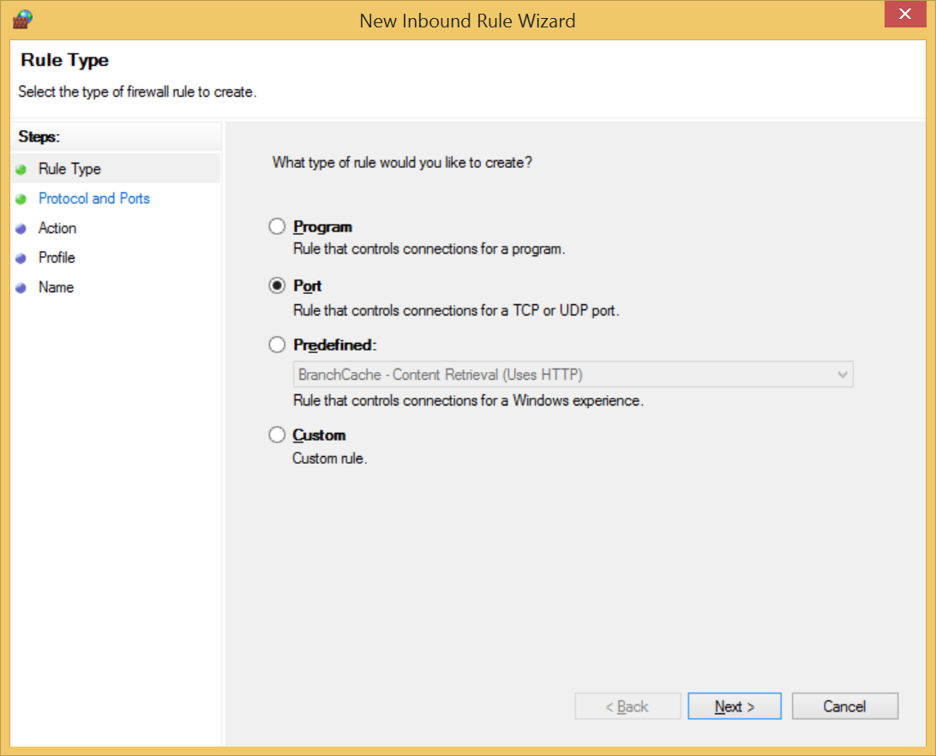
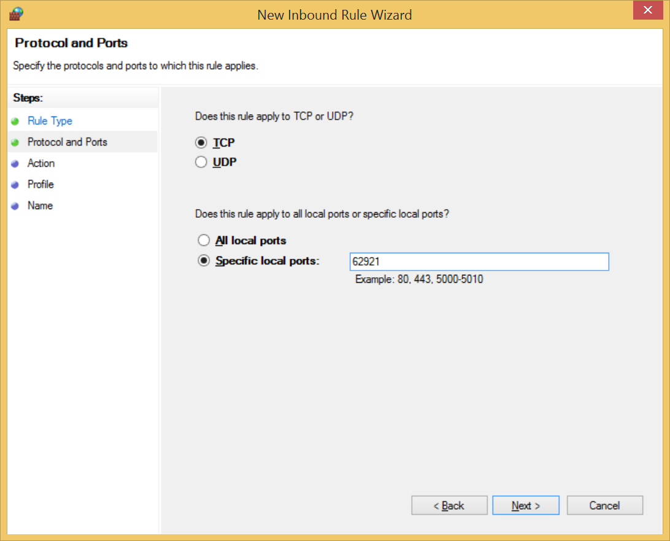
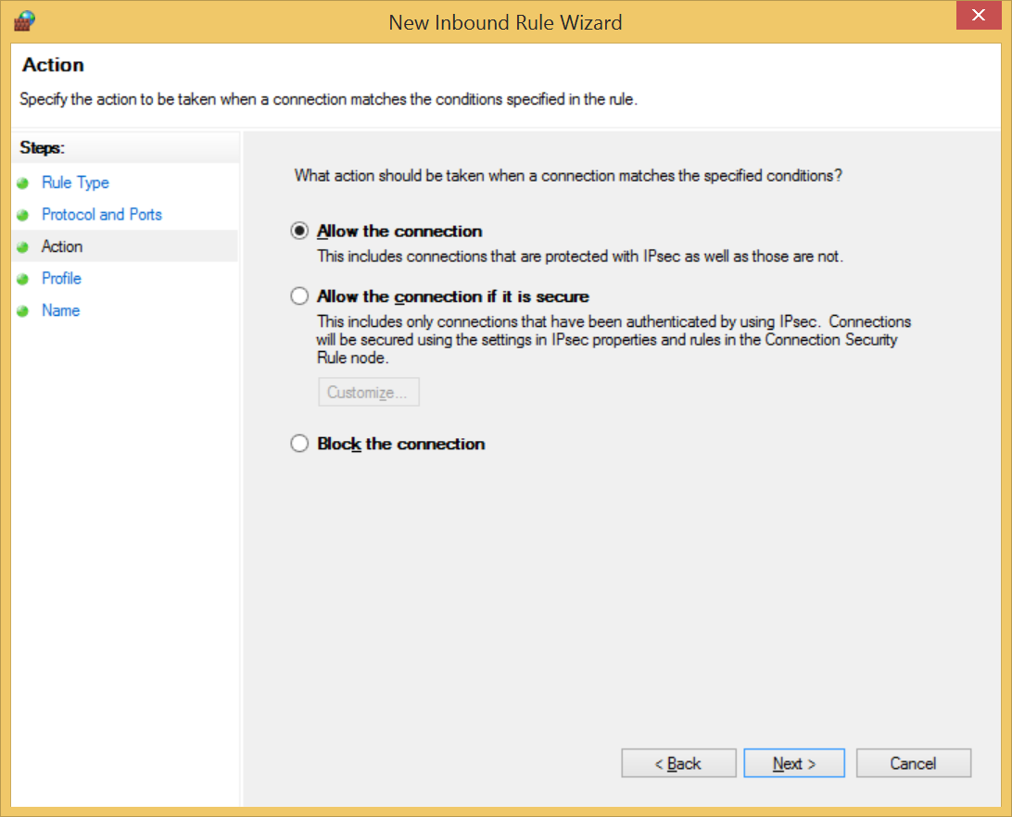
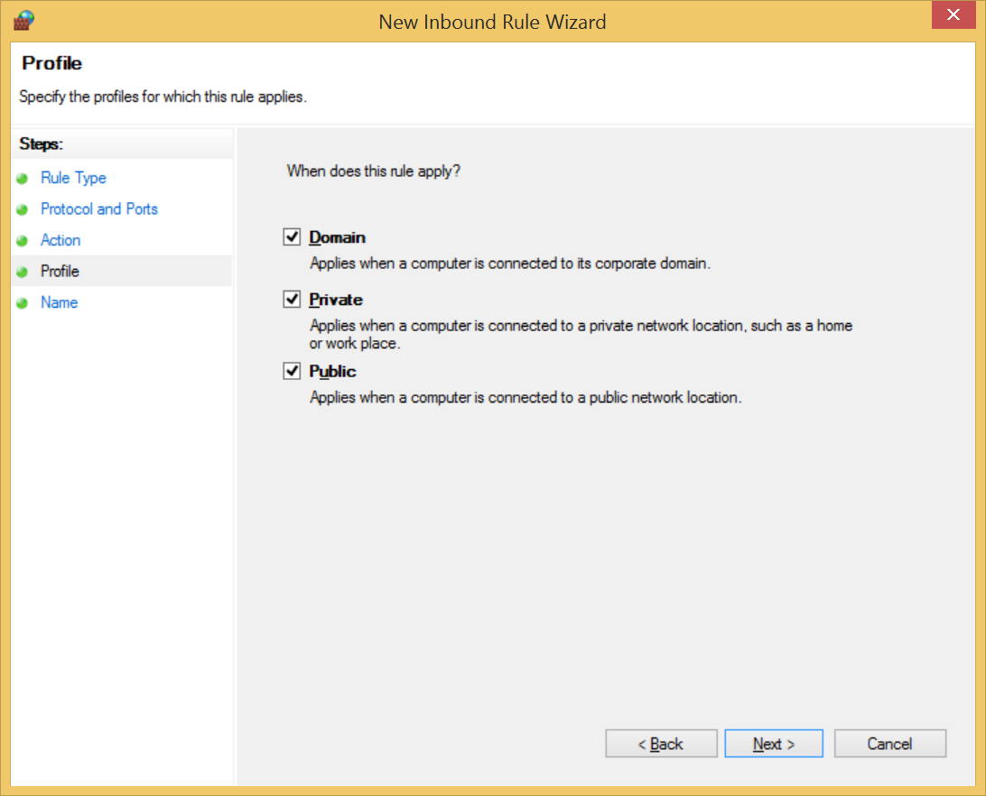

Configure Visual Studio
In the Web Server properties of both the Sif.Framework.EnvironmentProvider and Sif.Framework.Demo.Provider projects, modify the Project Url so that the computer name replaces “localhost”.

Configure the StudentPersonal Consumer
Update the SifFramework.config file and replace the “localhost” part of the consumer.environment.url value to use the computer name.

Configure the Environment definition
In the Sif.Framework.Demo.Setup project, update the “Data files/EnvironmentResponse.xml” file by replacing URL reference to “localhost” with the computer name. Once done, run the Scripts\BAT\Demo execution\DemoSetup.bat script.
At this point, the demo can be re-run as per previous instructions.

